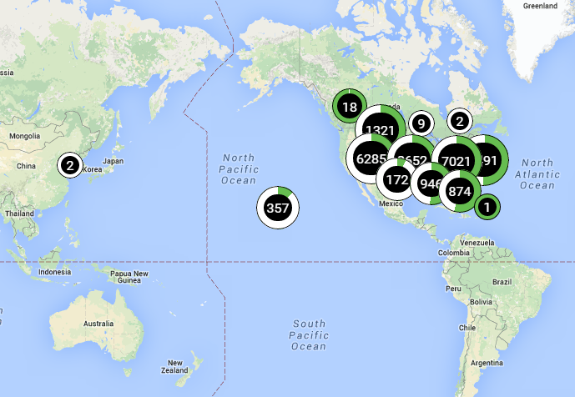

Figure 1: ChargePoint charging stations in the world

<https://na.chargepoint.com/charge_point>

ChargePoint

Founded in **2007,** ChargePoint (formerly Coulomb Technologies (CT)) is an electric vehicle infrastructure company, based in Campbell, California. CT’s aim was to offer ChargePoint Networked Charging Stations that includes *Public charging stations*; *A consumer subscription plan*; *Utility grid management technology* for electric utility companies (to smooth electrical demands on the grid)

In **January 2009**, the company's first charging stations were deployed in downtown San Jose that drivers can access through a prepaid plan.

Expansion

ChargePoint is currently the largest and most open electric vehicle (EV) charging network in the world, with more than 19,000 charging locations and a 70%+ market share. Since its first charging station installation, Coulomb charging stations have been in more than 27 US states, Canada and Europe.

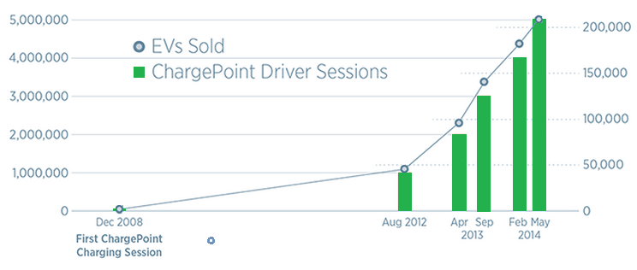

Figure 2:Every 7 seconds, a driver connects to a ChargePoint station and by initiating over 6.8 million charging sessions, ChargePoint drivers have saved over 6.2 million gallons of gasoline and driven 144 million gas free miles.

Ranked #1 by leading independent research firm (Navigant Research), ChargePoint makes advanced hardware and best-in-class cloud based software. The company also launched a $100 million lease financing fund with partner Key Equipment Finance that's meant to jump-start the spread of public charging infrastructure.

In America, the ChargePoint America project sees 1,800 240-volt charge stations being built. Sponsored by Coulomb Technologies, the $37 million project is backed by a $15 million DOE grant, provided through the Recovery Act. ChargePoint America has provided 4,600 networked charging stations to homes and public locations (October 2011), adding to the existing ChargePoint Network. The ChargePoint America project will collect data on vehicle use and charging patterns, which will be analyzed by DOE's Idaho National Laboratory.

It has announced its expansion into Europe, the Middle East and Africa with the opening of Coulomb’s European headquarters represented by 365 Energy Group, a venture of Estag Capital AG, in Berlin, Germany. Coulomb Technologies' ChargePoint public charging stations are also already in Australia.

Today

ChargePoint currently consists in three main products:

**ChargePoint Home** (level 1) - **CT4000** **family** of charging stations (level 2 – 25 RPH) - **ChargePoint Express 200** (Fast Charging – 200 RPH)

This three types of charging stations enable the ChargePoint company to aim at the entire EV market. ChargePoint targets companies and individuals to sell these charging stations. Manufacturing and R&D are actually let to “suppliers”. This strategy lead them to partner up with many companies, including car industries, electricity suppliers, …





Figure 3:EV: BMW I, Cadillac, Chevrolet, Fiat, KIA, Mercedes, Nissan, Smart, Volkswagen

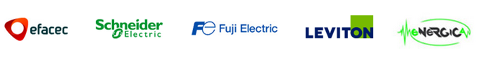

Figure 4: Commercial: Efacec, Schneider Electric, Fuji Electric, Leviton, Energica

Another main aspect of their strategy is the focus on customer services. The **ChargePoint mobile app** gives real-time network information (including the availability of charging locations throughout the nation). **ChargePoint Assure** covers all ChargePoint stations (one year parts and on-site labor warranty). All maintenance operations are covered by the **ChargePoint Station Management** (and done by a partner company, often selected among select national operations & maintenance firms). Finally, every aspect of policy, pricing, management, and reporting on a daily basis can be controlled via the **ChargePoint Cloud Services**. For example, through their ChargePoint account, drivers can keep track of their favorite charging spots and personal data, like how much money they are saving and their shrinking carbon footprint.

But ChargePoint has other advantages that lead customer to choose their services: **More charging locations** than anyone else (20,000+ charging spots and counting). Its charging stationsare **easy to find** (with the mobile app and real-time data, it’s easy to find available stations and start charging). **All car models** work on ChargePoint charging stations (e.g. CHAdeMO-compatible cars, SAE Combo-compatible cars). Plus, with **ChargePoint Express locations**, DC fast charging on our network, **long road trips** are easy. Last, but not least, **ChargePoint Home**: the world’s most advanced EV charging station for the home, and it’s also connected with all your public charging.

With a **dozen patents** since 2013, ChargePoint is obviously **leader in innovation**. Its strategy is to create, in order to **maintain the competitive advantage** they have over the competition. Indeed, doing so, they remain the leading company in the US on charging stations, and are the one company people turn to, as long as they **keep the lead** in **innovation** and **creativity**.

Conclusion

ChargePoint is currently the **obvious leader** of the American market for charging stations. They arrived **early** **on** **the** **market**, and have controlled it since by keeping on creating, innovating, and proposing new services. Today, they are the one company people turn to when it comes to charging stations.

In order to create the right products, they have choose to team up with many very successful companies, that ally quality and innovation (BMW, Mercedes, Volkswagen, Chevy…) and are the worldwide most successful companies in their domain, (Schneider Electric, Efacec, …). They thus use not only their partners’ skills in innovation and manufacturing, but also their brand image, creating for themselves a name that combines all those qualities.

Another winning strategy was the use of **many standards**. ChargePoint stations are compatible with the CHAdeMo fast-charging standard, but also the UE-US Combo standard, and also include level 1 & 2 charging. Right now, they keep their options open, by making any EV user able to use one of their charging stations, and try hard not to exclude any user.

Today, they are starting a strategy of expansion, targeting the EU and Australia. Far away from the issues of the battle to come between CHAdeMO (Asia) and Combo (EU+US) standards (see page ??), since they create combined products, they will try to impose a model that has been successful in the US. Plus, apart from Estonia (that has most of the territory covered with charging stations – see page ??), the majority of European countries have big investments to make, in order to become EV-compatible. Which, if they want to eventually be sustainable, they will have to do.